Operational Concept Description (OCD)

Combat Conflict

Team Number 4

Team members and roles

Tyler Bard- Quality Focal Point
Jai Khanna- Software Developer/ Prototyper
Mansi Negi- Software Developer/ Prototyper
Lisa Scaria- Operational Concept Engineer / Lifecycle Planner
Rijuta Kapoor- Requirement Engineer / Feasibility Analyst
Nicholas Funk- Software Developer / Prototyper
Christopher Hanford- Prototyper / UML Modeler
Tony Chun- Project Manager

04th December 2015

Version History
Date | Author | Version | Changes made | Rationale
10/07/15 | Rijuta Kapoor | 1.0 | - Original template for use for  Combat Conflict Project | - Initial draft for use for  Combat Conflict Project
11/23/2015 | Rijuta Kapoor | 2.0 | - Updated changes in the project from second ARB | - Consistent format

Table of Contents
Operational Concept Description (OCD) i
Version History ii
Table of Contents iii
Table of Tables iv
Table of Figures v
1. Introduction 1
1.1 Purpose of the OCD 1
1.2 Status of the OCD 1
2. Shared Vision 2
2.1 Benefits Chain 3
2.2 System Capability Description 4
2.3 System Boundary and Environment 5
3. System Transformation 7
3.1 Information on Current System 7
3.2 System Objectives, Constraints and Priorities 7
3.3 Proposed New Operational Concept 9
3.4 Organizational and Operational Implications 12

Table of Tables
Table 1: The Program Model 2
Table 2: Level of Service Goals 7
Table 3: Relation to Current System 8

Table of Figures

Figure 1: Benefits Chain Diagram of Combat Conflict System…………………………… 3
Figure 2: Benefits Chain Diagram……………………………4
Figure 3: System Boundary and Environment Diagram of Combat Conflict System………………5
Figure 4: System Boundary and Environment Diagram……………………………6
Figure 5: Element Relationship Diagram of Combat Conflict System ……………………………9
Figure 6: Element Relationship Diagram……………………………10
Figure 7: Business Workflow Diagram of Combat Conflict System……………………………11
Figure 8: Business Workflows Diagram……………………………12

Introduction

Purpose of the OCD
This document provides, in detail, the shared visions and goals of the stakeholders of the Combat Conflict System. The success-critical stakeholders of the project are the Masters of Business Veterans, College Students and ELC Staff members.

Status of the OCD
The status of the OCD is currently at the deployment phase. The Combat Conflict System is deployed at the Client’s Server called the Digital Ocean.. The ELC Staff is the maintainer of the system.

Shared Vision
Table 1: The Program Model
Assumptions (Under what Business assumptions will this ‘model’ be true)
- Veterans find the Conflict Management System very useful.
- People want to improve their conflict management skills.
- People want to improve their conflict management skills by using a game or a video.

Stakeholders  (Who is accountable for the initiatives) | Initiatives  (What to do to realize benefits) | Value Propositions  (Benefits i.e Why) | Beneficiaries  (Who derives value)
- Developers  - Maintainers of the System  - Clients  - College Students  - Adult Learners with military experience  - Masters of Business Veterans (MBV)  - Executives of Corporates  - People enrolled in the Marshall Executive Program  - Experiential Learning Centre (ELC) Staff | - Build the new system from scratch  - Market the product developed to employees, students and veterans  - Training the ELC Staff members by explaining the working of the system  - Documentation (Creating the user manual for users to understand the system) | - Improve conflict management skills for MBV Students  - Resolve Conflicts in a team setting  - More of collaborative study than competitive study  - Improve team setting collaborative skills | - Veterans in the Marshall School of Business  - College Students  - Company Employees  - People Enrolled in Marshall Executive Education program

Benefits Chain
ASSUMPTIONS
-Veterans find the Conflict Management System very useful.
-People want to improve their conflict management skills.
-People want to improve their conflict management skills by using a game or a video.

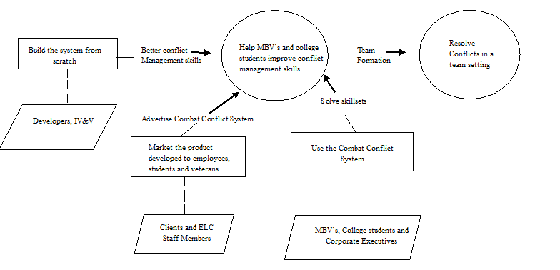

Figure 1: Benefits Chain Diagram of Combat Conflict System

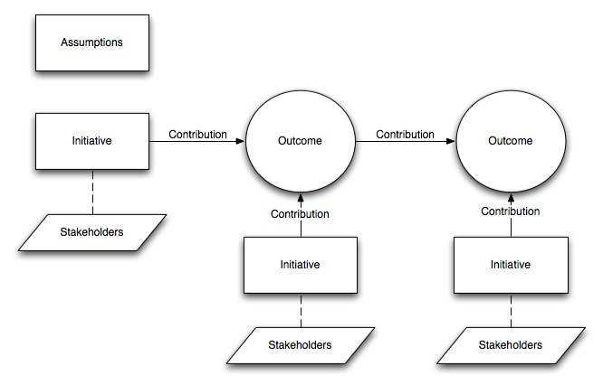
Figure 2: Benefits Chain Diagram

System Capability Description
  - The Combat Conflict System help veterans and civilians improve their conflict management skills in a team formation.
  - The target customers of the system includes the Veterans of the Marshal School of Business (MBVs), College students and people enrolled in Marshal Executive Program.
  - The system provides the veterans and civilians to solve their conflict management skills by experiencing real time scenarios.
  - The users of the system would like to adopt it as a medium to improve their conflict management skills because the system helps them experience the scenario and makes it interactive by continuous feedback.

System Boundary and Environment
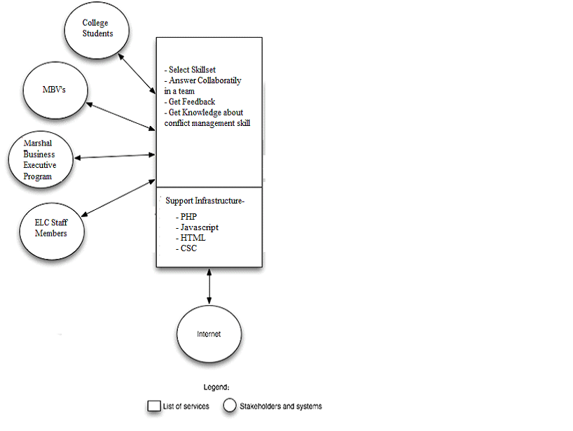
Figure 3: System Boundary and Environment Diagram of Combat Conflict System

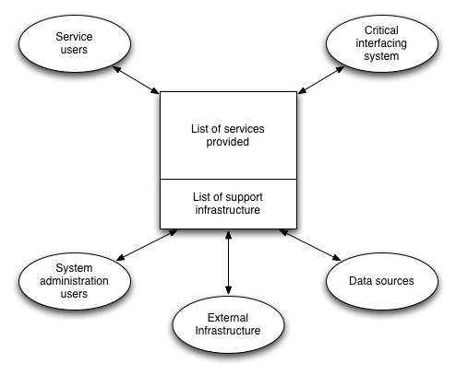
Figure 4: System Boundary and Environment Diagram

System Transformation

Information on Current System

Infrastructure
There is no current system.

Artifacts
There is no current system.

Current Business Workflow
There is no current system.

System Objectives, Constraints and Priorities

Capability Goals

Capability Goals | Priority Level
OC-1 Take up conflict management skillsets: The system allows the users to select a skillset in order to improve their conflict management skill. | Must have
OC-2 View Feedback: The system is capable of generating a feedback after every question which enables the users to understand how they react to the situation in comparison to other civilians and veterans. | Must have

Level of Service Goals
Table 2: Level of Service Goals
Level of Service Goals | Priority Level | Referred WinWin Agreements
LOS-1: Allow for an open environment for adult learners to learn from each other. | High | As a veteran, I can compare my decisions to the decisions civilians made so that I can compare my thought processes to theirs.
LOS-2: Create a way for the site to be dynamic and interesting for the user. | High | As a veteran, I want to see graphs on what decisions others made in the same situation so that I can see that I'm not alone in my thought processes.
LOS-3: Save the data anonymously about civilians and veterans to better understand how the two think differently. | High | As an Adult Learner, I can take the assessment so that I can judge how much I need to improve my conflict management skills.

Organizational Goals
OG-1: Help the students and veterans of Marshall School improve their conflict management skills.
OG-2: Generate a comparison to judge how differently the civilians and veterans react to a situation.
OG-3: Help students and veterans improve conflict management skills in a team collaboration.

Constraints
CO-1: Zero Monetary Budget: The selected NDI/NCS should be free or no monetary cost.

Relation to Current System
Table 3: Relation to Current System
Capabilities | Current System | New System
Roles and Responsibilities | N/A | Developers and Maintainers
User Interactions | N/A | Website Users and Admin
Infrastructure | N/A | Wordpress
Stakeholder Essentials and Amenities | N/A | Reliability of website, low/no cost
Future Capabilities | N/A | Scalability

Proposed New Operational Concept

Element Relationship Diagram
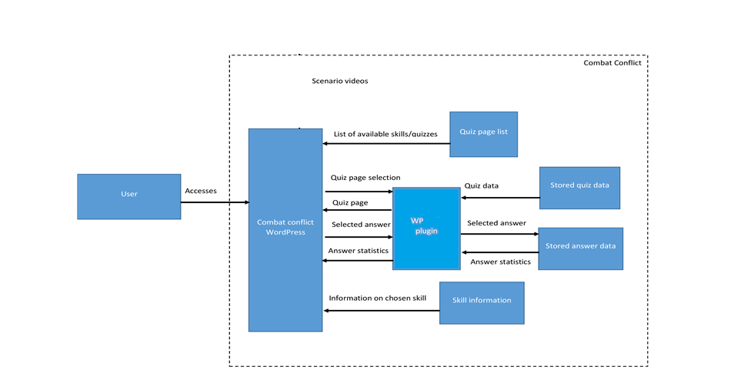
Figure 5: Element Relationship Diagram of Combat Conflict system
(NDI-intensive project)
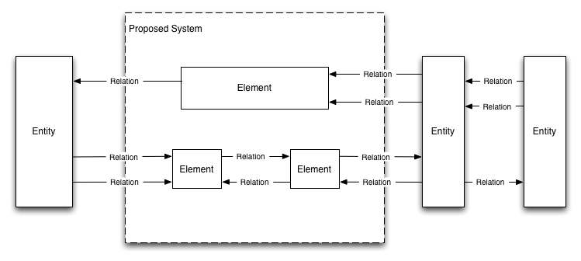
Figure 6: Element Relationship Diagram

Business Workflows
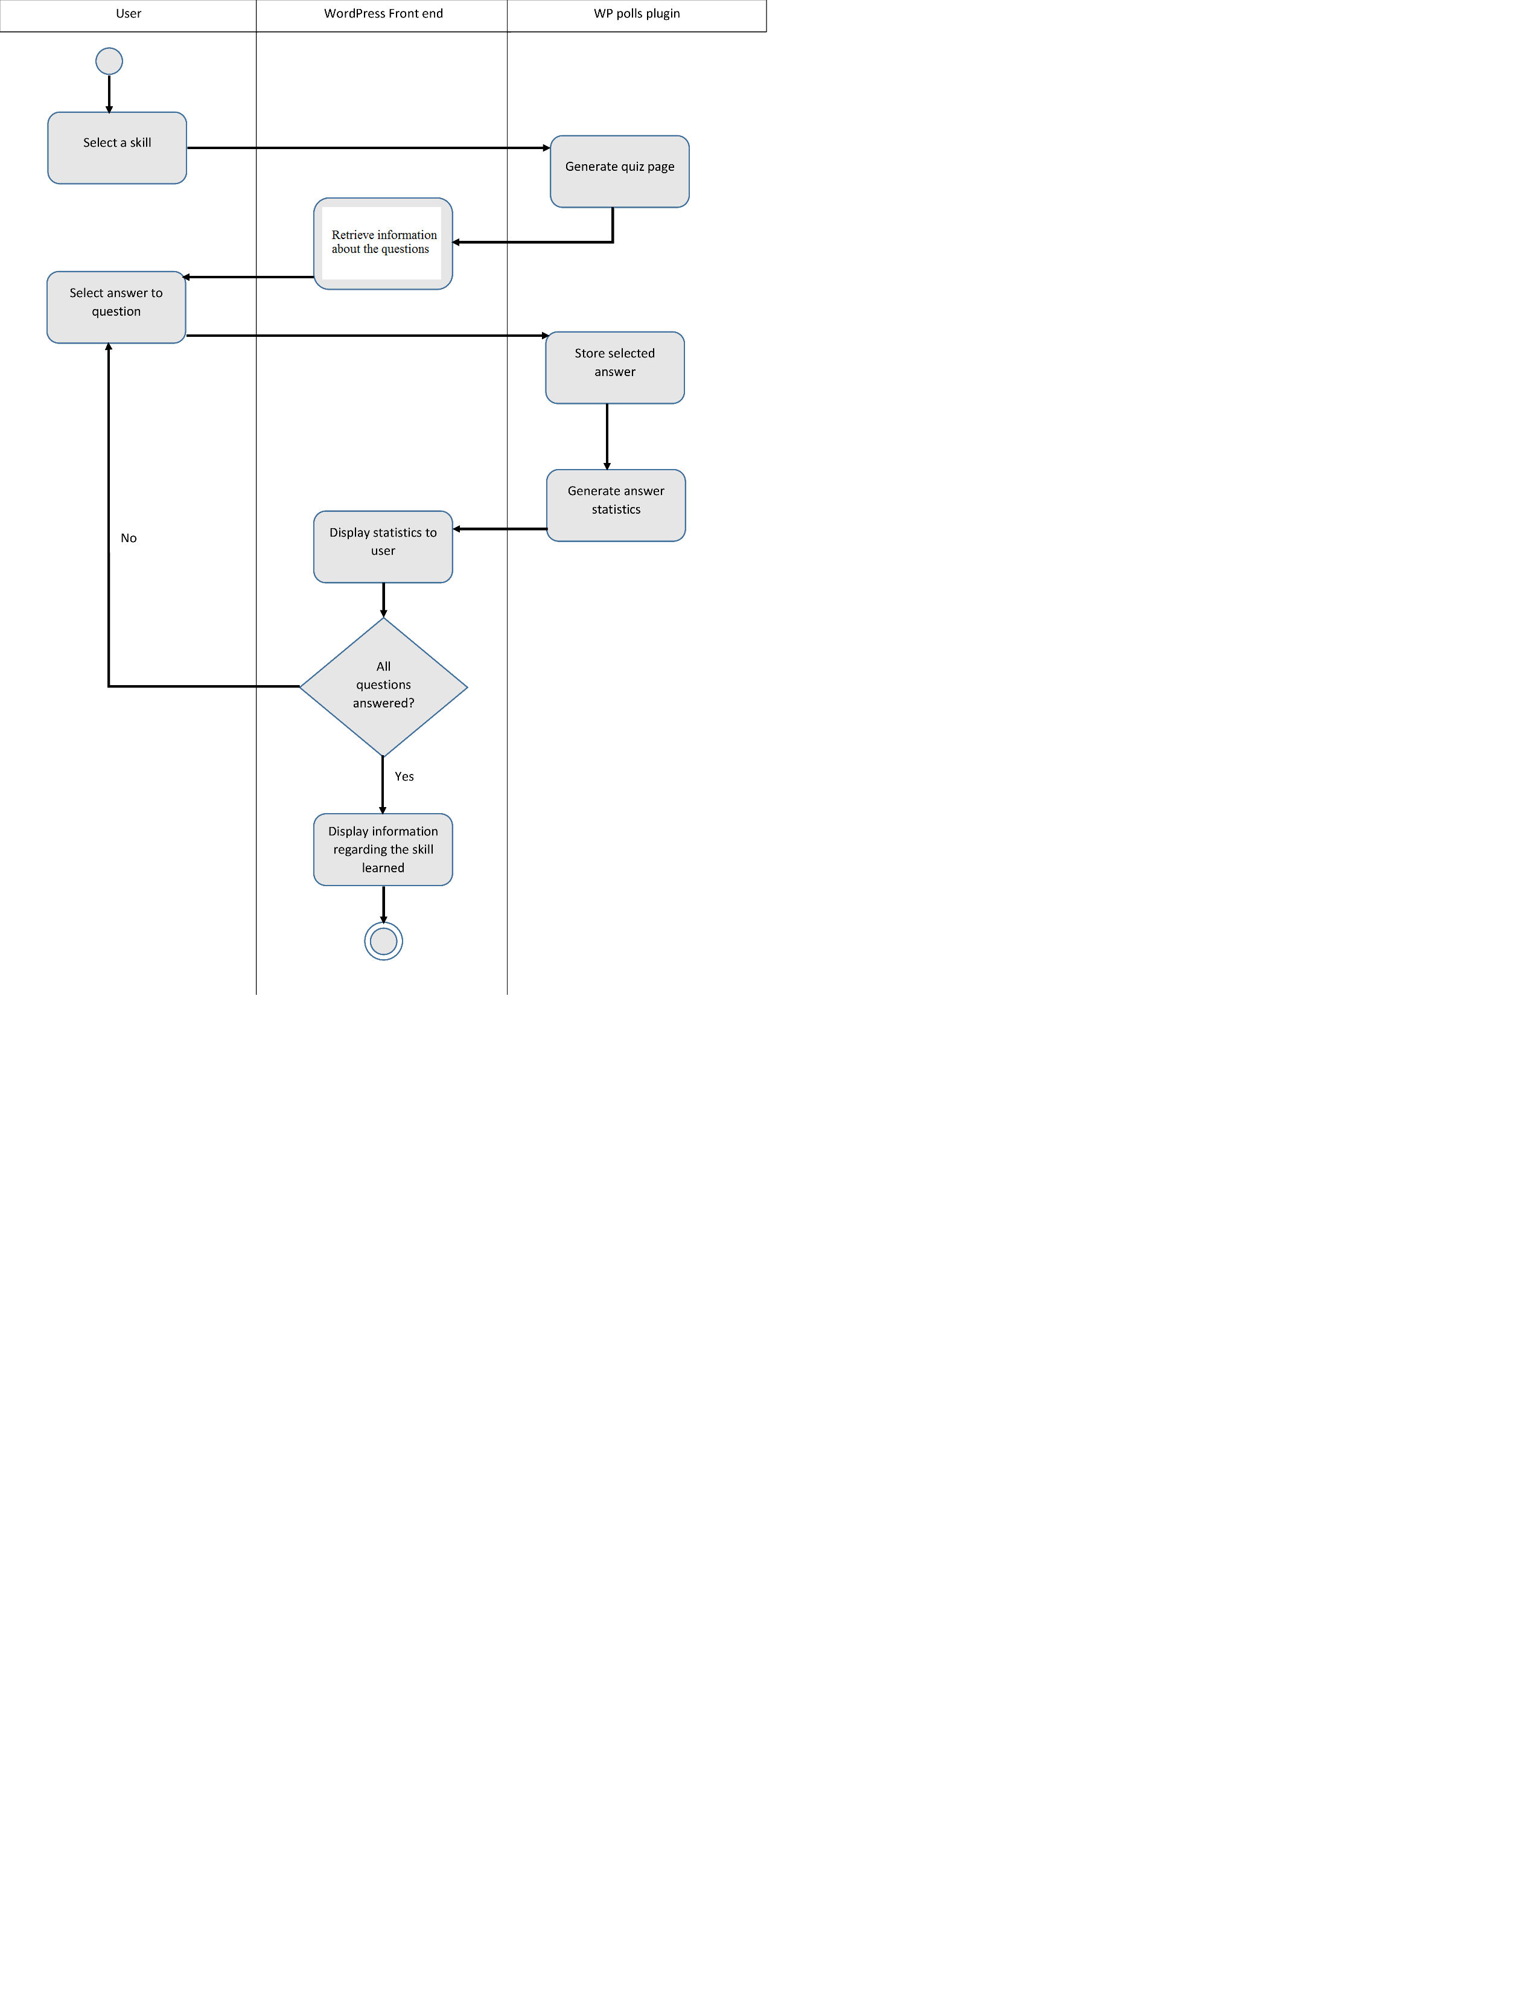

Figure 7: Business Workflow Diagram of Combat Conflict System

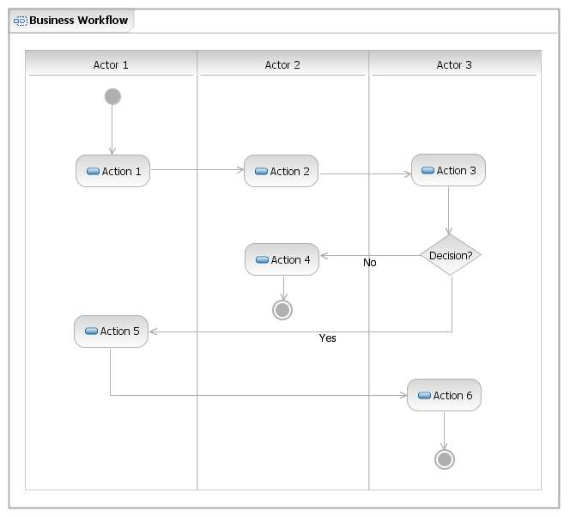
Figure 8: Business Workflows Diagram

Organizational and Operational Implications

Organizational Transformations
- The need to hire a new system maintainer to take care of the system
- The change in the class structure to help students use the system in a collaborative team fashion

Operational Transformations
- The veterans will be using an online system in order to improve their conflict management skills.
- The Professors of Marshall School and ELC help their students and veterans improve their conflict management skills by the use of an online system which is both interactive and responsive.

